**LAB#14**

**OBJECT: Convert binary no into excess-3 code.**

**APPARATUS:**

* 74LS08
* 74LS04
* 74LS32
* Bread Board
* Connecting Wires
* LED
* DC Supply

**SYMBOLS:**

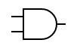

AND GATE

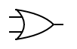

OR GATE



NOT GATE

**TRUTH TABLE:**

|  |  |  |  |  |  |  |  |  |
| --- | --- | --- | --- | --- | --- | --- | --- | --- |
| **X** | **A** | **B** | **C** | X3 | X2 | X1 | X0 | X+3 |
| 0 | 0 | 0 | 0 | 0 | 0 | 1 | 1 | 3 |
| 1 | 0 | 0 | 1 | 0 | 1 | 0 | 0 | 4 |
| 2 | 0 | 1 | 0 | 0 | 1 | 0 | 1 | 5 |
| 3 | 0 | 1 | 1 | 0 | 1 | 1 | 0 | 6 |
| 4 | 1 | 0 | 0 | 0 | 1 | 1 | 1 | 7 |
| 5 | 1 | 0 | 1 | 1 | 0 | 0 | 0 | 8 |
| 6 | 1 | 1 | 0 | 1 | 0 | 0 | 1 | 9 |
| 7 | 1 | 1 | 1 | 1 | 0 | 1 | 0 | 10 |

**KARNAUGH MAP**

K-MAP FOR X0:

|  |  |  |
| --- | --- | --- |
|  | $$\overline{C}$$ | $$C$$ |
| $$\overline{A }\overline{B}$$ | 1 | 0 |
| $$\overline{A }B$$ | 1 | 0 |
| $$AB$$ | 1 | 0 |
| $$A\overline{B}$$ | 1 | 0 |

**X0= $\overline{C}$**

K-MAP FOR X1:

|  |  |  |
| --- | --- | --- |
|  | $$\overline{C}$$ | $$C$$ |
| $$\overline{A }\overline{B}$$ | 1 | 0 |
| $$\overline{A }B$$ | 0 | 1 |
| $$AB$$ | 0 | 1 |
| $$A\overline{B}$$ | 1 | 0 |

**X1= BC + $\overline{B}\overline{C}$ = $\overline{B⊕C}$**

K-MAP FOR X2:

|  |  |  |
| --- | --- | --- |
|  | $$\overline{C}$$ | $$C$$ |
| $$\overline{A }\overline{B}$$ | 0 | 1 |
| $$\overline{A }B$$ | 1 | 1 |
| $$AB$$ | 0 | 0 |
| $$A\overline{B}$$ | 1 | 0 |

**X2= $\overline{A}$ C + $\overline{A}B$ + A $\overline{B}\overline{C}$ = $\overline{A}$ (C+B) + A $\overline{B}\overline{C}$**

K-MAP FOR X3:

|  |  |  |
| --- | --- | --- |
|  | $$\overline{C}$$ | $$C$$ |
| $$\overline{A }\overline{B}$$ | 0 | 0 |
| $$\overline{A }B$$ | 0 | 0 |
| $$AB$$ | 1 | 1 |
| $$A\overline{B}$$ | 0 | 1 |

**X3= AB + AC = A(B+C)**

**CIRCUIT DESIGN:**

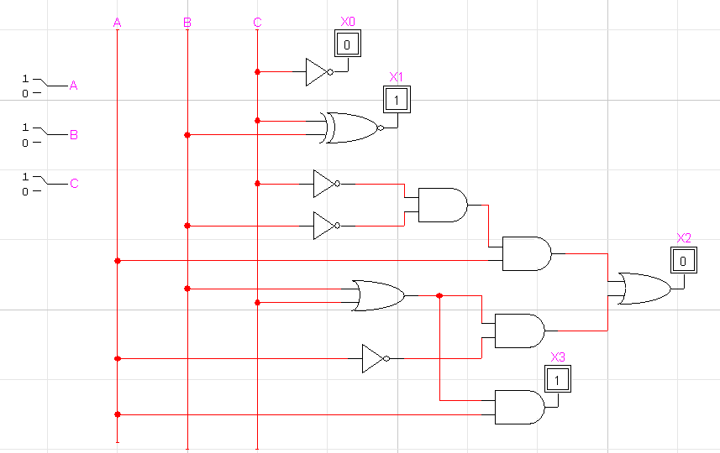

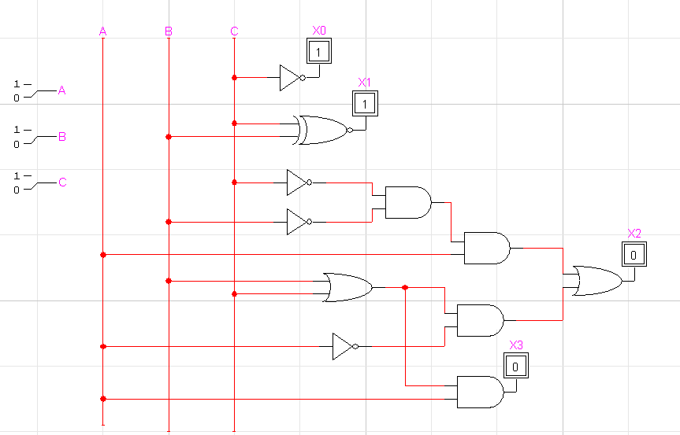

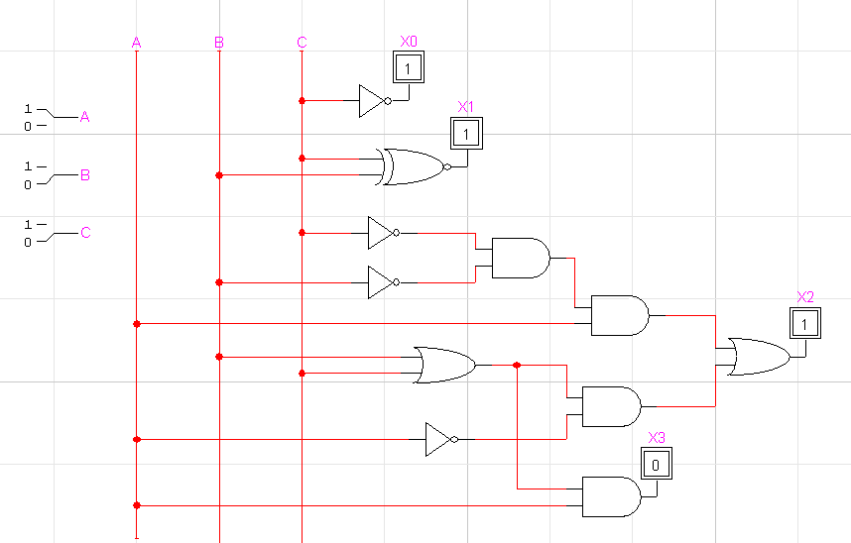

**CONCLUSION:**

The Binary to Excess-3 Code conversion is accurate.